- Once open, search for “WapellaCC”

How to Setup Church App
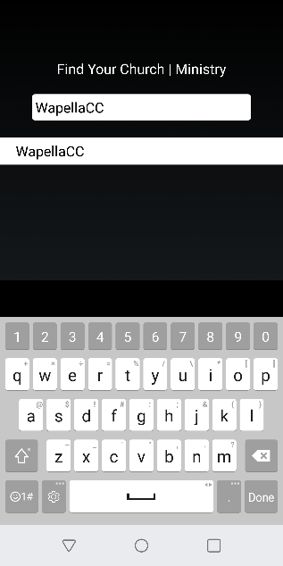
- Select ‘WapellaCC’ and click ‘Save’
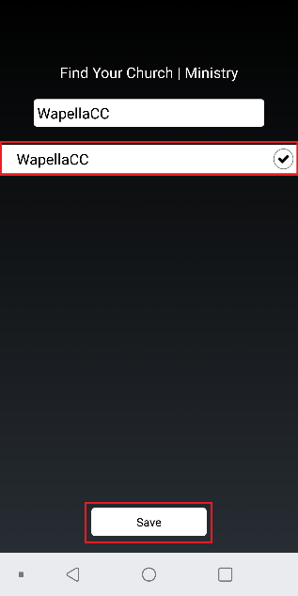

- Select ‘My Ministry’ when pop up comes.
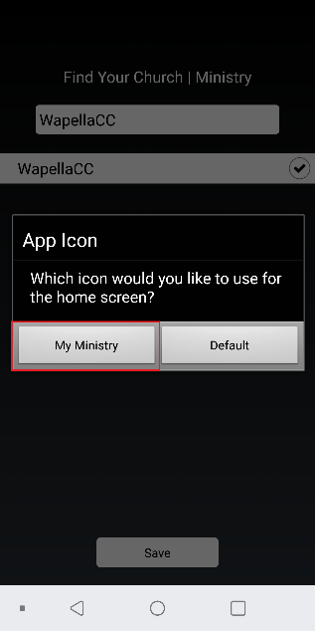
- Once complete select 3 lines in top right to access menu.
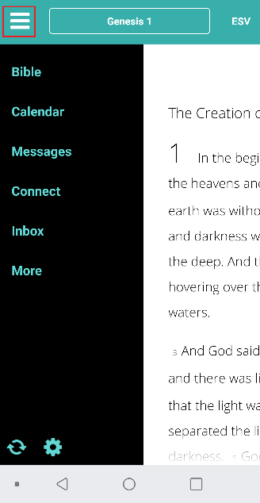

- Once complete app will look like below.
